CHAPTER IV
EXTERNAL INTERFACE REQUIREMENTS

This chapter discusses the interfaces of HydroSense, focusing on the interaction between hardware and software components. It outlines the web applications screen layouts and corresponding purposes, providing a detailed overview of the user interface elements and their functionalities. Additionally, this chapter identifies the hardware interfaces, explaining how sensors and microcontrollers work together to gather and process water quality data. The chapter covers the software interfaces, detailing the programming languages and development tools that facilitate seamless data integration and visualization. Furthermore, it elaborates on the communication interfaces, highlighting the critical role of the ESP32 web server in delivering real-time water quality information to users over a network.

4.1 User Interfaces
HydroSense offers a comprehensive platform with four sections: homepage, data insights, hydrology resources, and about. First, the homepage provides real-time water quality monitoring, interactive pH, TDS, turbidity, temperature gauges, and logging and recommendation features. Second, the data insights section presents detailed analysis and historical data through interactive graphs and tables, allowing users to track water quality trends. Third, the hydrology resources section serves as an educational hub, offering information on water safety, pH levels, and treatment methods through articles and videos. Lastly, the About section introduces the HydroSense project and its developers, explaining the systems mission and technical setup. Each section shares a consistent layout with a top navigation bar for seamless access, ensuring a user-friendly experience across the application.
4.1.1 Setup Interface
Figure 8 shows the setup interface for connecting HydroSense to the Wi-Fi network. At the top, it lists the available networks with respective signal strengths. Below the list is a form to input the SSID and password for the selected network, with an option to show the password input. Two "Save" and "Refresh" buttons are provided to save the settings or refresh the network list. At the bottom, a red message indicates that the device is "Not connected" to the network with SSID "1234568," stating "AP not found." It means that the previous Wi-Fi that HydroSense is connected to is not present. The interface is accessed when connecting to the HydroSense Wi-Fi AP at the local IP address '192.168.4.1'.

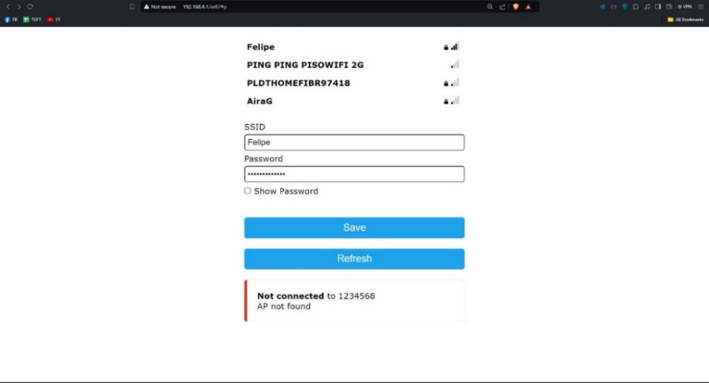
Figure 8. Setup Interface.

Figure 9 shows the process of saving Wi-Fi credentials and attempting to connect the HydroSense device to a network. A message box on the page states, "Saving Credentials" and "Trying to connect ESP to network." It also advises, "If it fails reconnect to AP to try again," suggesting that if the connection attempt is unsuccessful, the user has to reconnect to the Access Point (AP) and try again.

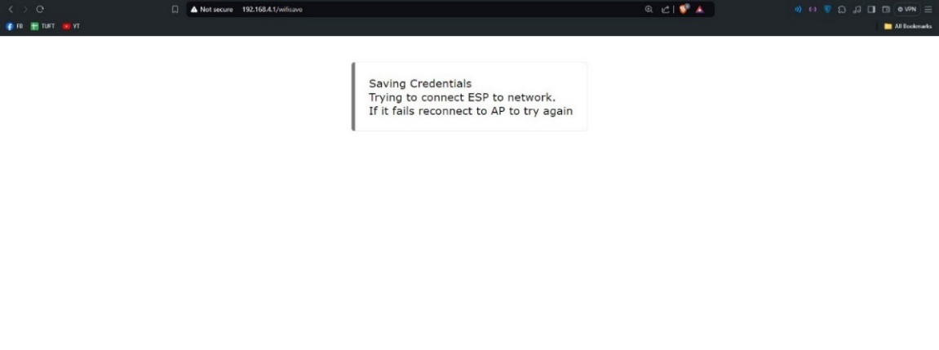
Figure 9. Saving Credentials.

4.1.2 Homepage Interface
The HydroSense homepage interface is designed for real-time water quality monitoring, showing four gauges that display key measurements: pH level, TDS level, turbidity level, and temperature. Each gauge is color-coded for quick visual assessment and is clearly labeled to enhance user understanding. Below the gauges are two functional buttons: "Start Logging" and "Show More." The "Show More" button provides detailed recommendations for water treatment, explaining the significance of each parameter. The interface also includes a navigation menu with links to "Data Insights," "Hydrological Resources," and "About Us," offering users access to additional information and resources. The "Start Logging" button in Figure 10 creates a .csv le that records the sensor data and then redirects the user to the Live Data page.

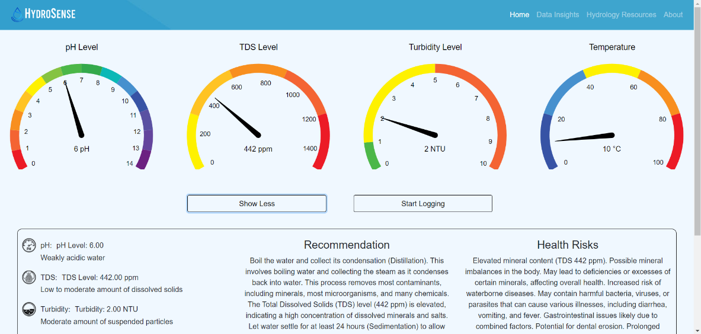Figure 10. Homepage.

Figure 11 depicts the Live Data page. The page features a line graph labeled "Sensor Data" at the top, which plots measurements of temperature (°C), TDS (ppm), turbidity (NTU), and pH over time, with each parameter represented by a unique color. The page also includes a "Recommendation" section, which states that the water is safe to drink, summarizing the current water quality status. A table below the graph lists recent measurements, showing timestamps alongside the corresponding temperature, TDS, turbidity, and pH values. A recommendation section indicates that the water is safe to drink, summarizing the current water quality status. The "Stop Logging" button stops data logging, saves it to a .csv le, and redirects to the Data Insights page.
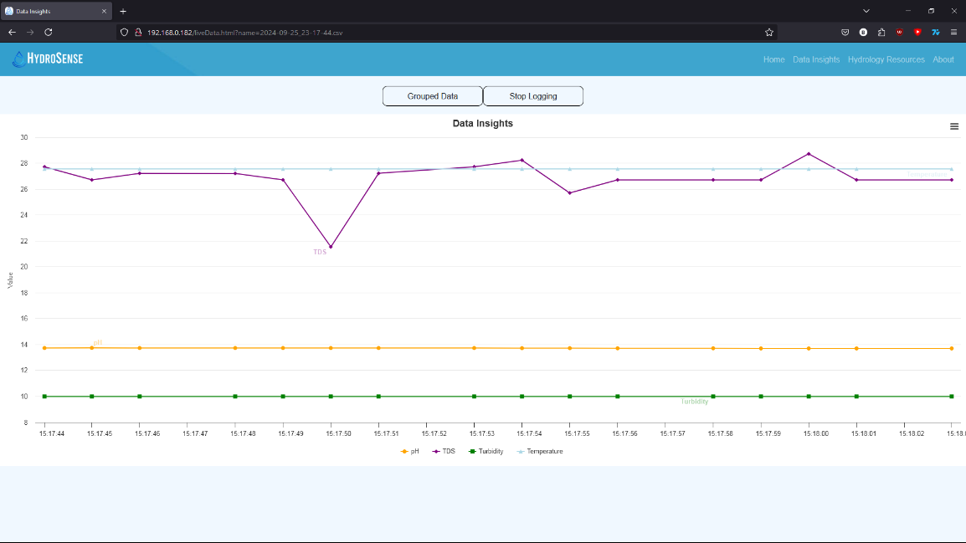
Figure 11. Live Data.

4.1.3 Data Insights Interface
Figure 12 displays the Data Insights interface of HydroSense, showcasing a comprehensive view of water quality data. At the top, a line graph titled "Sensor Data" presents historical measurements of temperature (°C), TDS (ppm), turbidity (NTU), and pH over time, each represented by a distinct color. A menu in the upper right corner offers options to view the chart in full screen, print it, or download it in various formats, including .csv. Below the graph, is a recommendation section summarizing the water quality status. The interface also includes a table listing recent sensor data with columns for time, temperature, TDS, turbidity, and pH values. On the left side, a panel labeled "Saved Data Files" lists previously recorded data files with options to delete them. This interface allows users to monitor real-time trends and access historical data for better decision-making. The intuitive layout ensures easy navigation and quick access to critical information.
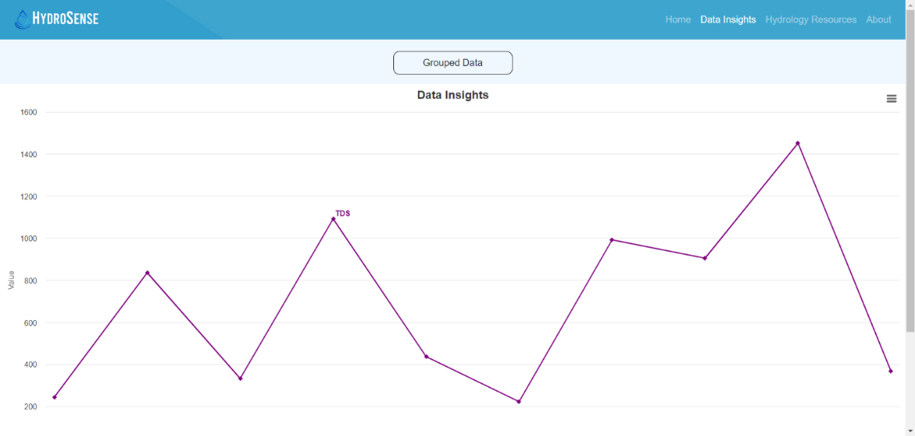
Figure 12. Data Insights Interface.

4.1.4 Hydrology Resources Interface
Figure 13 shows the Hydrology Resources page. It reveals a comprehensive list of topics related to water quality and treatment. Below the search bar and filter buttons, the page includes expandable sections for "Water Safety," "pH Level," "Turbidity Level," "TDS Level," "Water Temperature," and several methods of water treatment, such as "Filtration," "Aeration," "Water Distillation," "Sedimentation," "Boiling Water," "Water Treatment," and "Alkaline Water." Each section contains detailed information and resources to educate users on these specific aspects of hydrology. This layout provides a structured way for users to access and explore various topics related to water quality and treatment techniques. This makes it a practical resource for water quality education. The page also provides links to external resources, such as articles and video tutorials, for further learning. Its user-friendly design ensures easy navigation and accessibility for users at all knowledge levels.
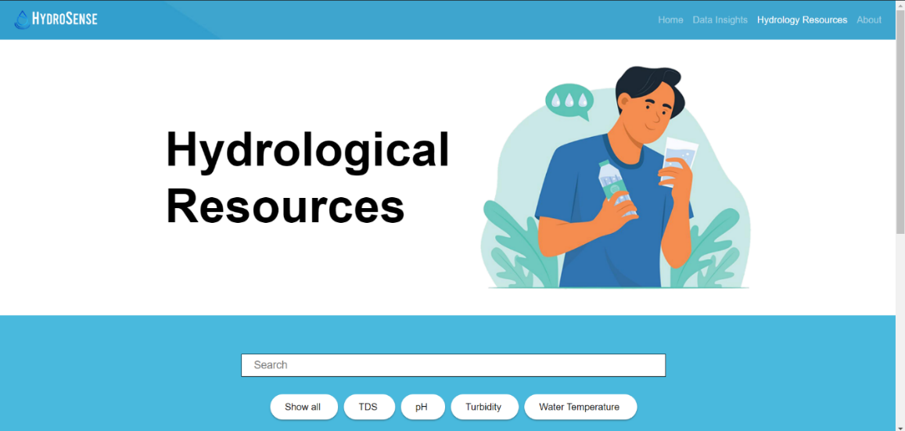
Figure 13. Hydrology Resources Interface.

Figure 14 shows a pop-up window when clicking on the "Water Safety" section on the Hydrology Resources page of HydroSense. The window briefly describes water safety, explaining its importance in ensuring that water used for drinking, recreation, and environmental purposes meets quality standards and is free from contaminants. The pop-up includes an embedded YouTube video offering an educational resource. Below the video, there are buttons labeled "Guide," "Article 1", "Article 2", and "Article 3", which provide additional resources for users to explore for more in-depth information about water safety. This feature enhances the user experience by integrating multimedia content that supports varied learning styles and preferences. HydroSense provides easy access to valuable resources on water safety. This promotes informed decision-making for safer water practices. This allows users to explore various topics in more depth. As a result, users enhance their understanding of essential water safety measures directly from the Hydrology Resources page.
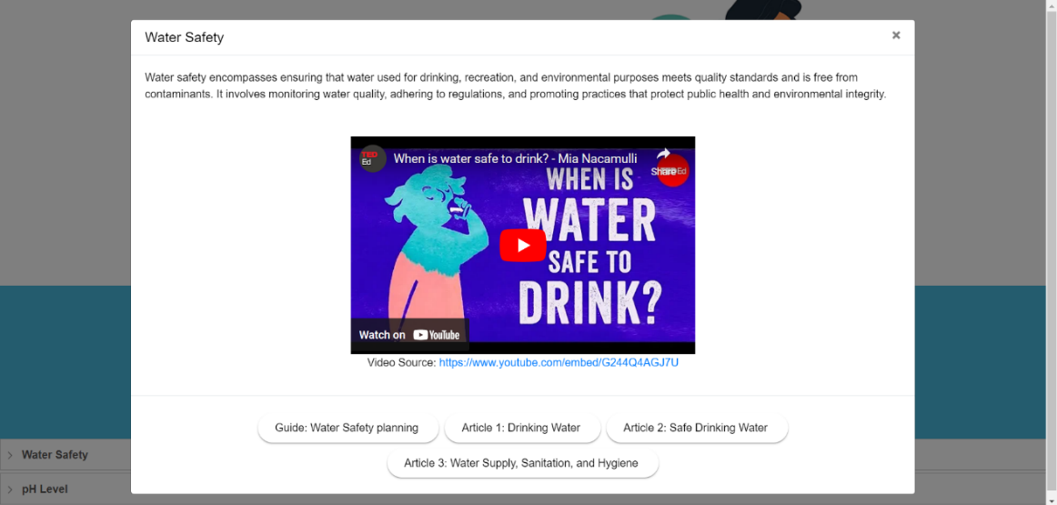
Figure 14. Hydrology Resources Popup.

Figure 15 provides a detailed view of the Hydrology Resources page after selecting the "pH" filter button just below the search bar. When this filter is activated, the page dynamically updates to showcase content specifically related to pH, streamlining the users focus on this aspect of water quality. The updated page layout features two prominent expandable sections labeled "Water Safety" and "pH Level." These sections are designed to house content pertinent to the pH filter, ensuring that all displayed information and resources are directly related to the pH of water. Users are able to interact with these expandable sections to reveal in-depth material on how pH levels affect water quality and safety, including details on the significance of maintaining appropriate pH levels, common issues associated with pH imbalances, and best practices for monitoring and adjusting pH. This targeted filter functionality enhances the user experience by providing a streamlined path to explore relevant topics, facilitating a more efficient and focused search for information about pH and its implications for water safety.

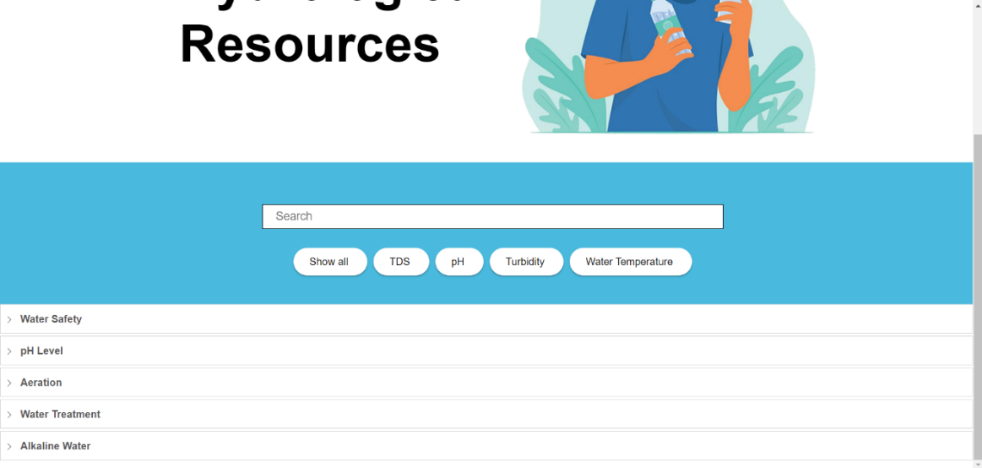
Figure 15. Hydrology Resource Toggle.

Figure 16 displays the Hydrology Resources page after using the search bar to look for the keyword "tds." The search results are filtered to display only the "TDS Level" section at the bottom, indicating that this section contains information relevant to the Total Dissolved Solids (TDS) keyword. This functionality allows users to quickly locate, and access specific topics related to their search query, streamlining the process of finding detailed information on water quality parameters. Users are able to refine their search with additional keywords further or explore related topics through the filter buttons provided. This interface design enhances user efficiency by offering intuitive search and navigation features within the HydroSense application. Additionally, tooltips and concise descriptions are integrated to assist users in understanding the context and significance of the displayed results, promoting a user-friendly experience.

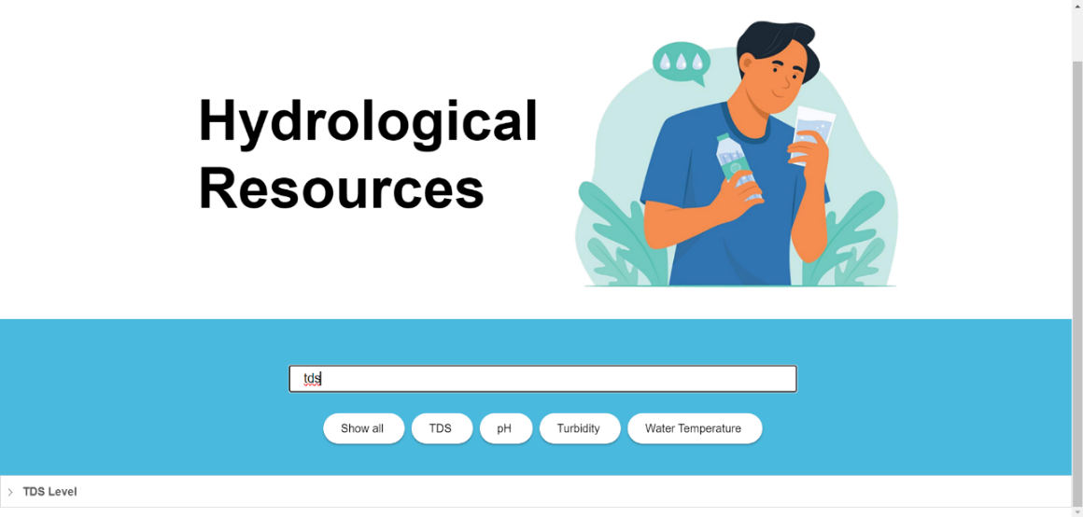
Figure 16. Hydrology Resources Search.

4.1.5 About Interface
Figure 17 shows the About page of HydroSense. It introduces the project with a visually engaging banner featuring clear water and the system "Clean Water, Clear Knowledge," emphasizing its focus on providing accurate water quality information. The page outlines HydroSense as an innovative web application offering tailored water purification suggestions based on real-time sensor readings, analyzing data such as TDS, turbidity, temperature, and pH. The technical setup includes an ESP32-WROOM-32D microcontroller connected to an Arduino Nano and various sensors, facilitating efficient data processing and visualization through a microSD card and OLED display. Additionally, the page highlights the developers, "Stealthy Kitten," showcasing the developers with their respective roles. This section provides a comprehensive overview of HydroSense mission, technological framework, and the developers behind its creation.

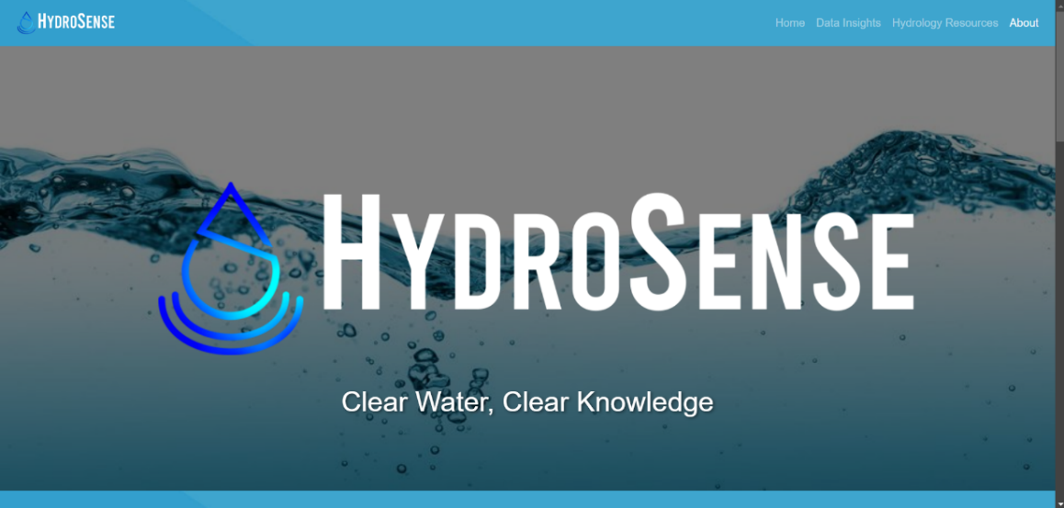
Figure 17. About Interface.

4.2 Hardware Interfaces
HydroSense is a sophisticated system that integrates software and hardware components to provide real-time water quality monitoring and analysis. The hardware interface of HydroSense includes an ESP32-WROOM-32D microcontroller connected to an Arduino Nano, which serves as the core processing unit for sensor data collection. Various sensors are integrated into the system to measure key parameters such as pH, TDS, turbidity, and temperature, transmitting data through interface boards. This setup enables precise and continuous monitoring of water quality. The microcontroller interfaces with an OLED display for real-time data visualization and a microSD card for logging sensor data and storing web server les. While HydroSense is accessible via a web-based application, the hardware components are essential for capturing accurate water data. This makes the system suitable for deployment in various locations where monitoring is critical. Users are able to access the application through any device with a web browser, although using a desktop or tablet with a larger screen enhances the visualization of complex data and graphs.
4.2.1 OLED Screen Interface
Figure 18 shows that the OLED screen of the HydroSense system provides a convenient and immediate way to view real-time water quality metrics directly from the hardware, offering a critical interface for on-site monitoring. This compact display prominently shows the device IP address, facilitating network communication and enabling seamless data monitoring from remote locations through the web application. In addition to the IP address, the screen presents crucial water quality parameters, including the current temperature, Total Dissolved Solids (TDS) level, turbidity, and pH level, giving users comprehensive insights into water conditions at a glance. By consolidating this information into a single, easily accessible display, users efficiently monitor essential water quality metrics on the spot without needing to go into the web interface, enhancing both usability and convenience. This capability is especially valuable in remote or eld settings, where quick access to water quality data is able to inform immediate decision-making and ensure timely interventions. Furthermore, the straightforward presentation of data on the OLED screen supports users of all technical levels, making HydroSense a versatile tool for various applications in water quality management. Its robust design and clear readability under diverse environmental conditions make it a reliable solution for field professionals.

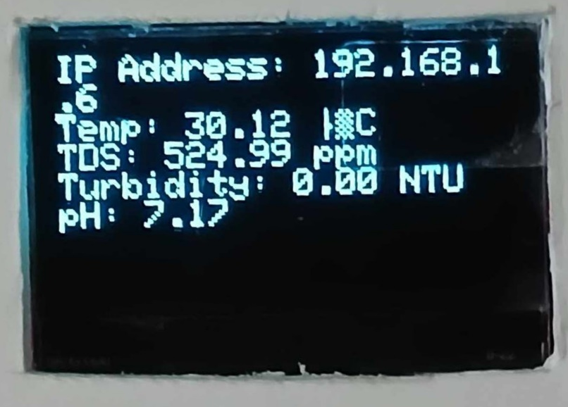
Figure 18. OLED Screen Interface.

4.3 Software Interfaces
The developers carefully integrated software interfaces that efficiently interact with the underlying hardware to provide accurate water quality monitoring and analysis. The system utilizes programming languages like C++ and Javascript to manage sensor data collection, processing, and transmission. The use of .csv les to store sensor data and Highcharts for charting .csv les to be viewed in the application. Internet protocols, including Hypertext Transfer Protocol (HTTP) and web servers, facilitate real-time data exchange between the hardware and the web-based application, enabling users to access current and historical water quality data through a user-friendly interface.
4.3.1 Browser
HydroSense is a web-based application designed to operate seamlessly on any device equipped with a modern web browser. The application has been thoroughly tested on popular browsers, including Google Chrome, Firefox, and Brave, to ensure compatibility and performance across different platforms. Developers used these browsers to verify that the web application maintains consistent functionality and interface quality, regardless of the users’ browser choice. Internet connectivity is critical to application performance, relying on real-time data transmission from the hardware to the web interface. A stable and fast internet connection enhances the applications responsiveness and user experience, providing accurate and timely water quality insights.

4.4 Communication Interfaces
This section discusses the components and technologies facilitating data transmission between the HydroSense web application and its users. It explains how data transmission is initiated and delivered, ensuring efficient interaction. Additionally, the section covers the hosting platform that supports seamless user access to the application. Overall, it provides an overview of the communication processes that enable real-time data exchange within HydroSense.
4.4.1 ESP32 Web Server
HydroSense utilizes an integrated web server hosted directly on the ESP32 microcontroller, enabling local data processing and web application hosting. The application is developed using C++ and JavaScript to create interactive features and real-time data visualization. By hosting the web application on the ESP32, HydroSense operates independently of external servers, ensuring data security and immediate access. The ESP32 web server handles requests from connected devices, delivering water quality data efficiently to users' browsers via HTTP and WebSocket protocols.
This chapter outlines the various interfaces designed and utilized by the HydroSense application. The team has explored the screen layouts, presenting a graphical representation of what users are able to expect when accessing and navigating through the system. The developers have provided detailed descriptions of hardware and software interfaces, illustrating how they work together to deliver accurate water quality data. Each section has highlighted the importance of these interfaces in ensuring a seamless user experience, focusing on real-time data processing and accessibility. The chapter also emphasizes the role of intuitive design in minimizing the learning curve for users of diverse technical backgrounds. Detailed case studies demonstrate how the interfaces facilitate quick decision-making and enhance operational efficiency.
Additionally, future recommendations for interface improvements are provided to address scalability and evolving user needs. The integration of feedback from initial users has been instrumental in refining the systems usability and performance. Looking ahead, the development team plans to incorporate advanced features, such as predictive analytics, to further empower users in proactive water quality management.

